Project Report

* Introduction:-

Management of a residential housing society is a very hectic and trouble-taking task if it comes to on a particular person to handle. The efficient method to deal with this kind of situation is online sources like website of housing society management system.

This report is regarding the Project on UI/UX designing titled “BUMA” (residential housing society management System). This particular project has been created by using Figma. Figma is a very efficient and user friendly platform for freshy students who are interested in web designing.

* Objective:-

The main objectives of this Project are as follows:-

1. Reliability
2. User friendly
3. Efficient
4. Easy maintenance
5. Easy access

* Features:-

The project consists of following modules:-

1. **Home**:- This page contains briefing about all the other pages.
2. **Login**:- This page contains login credentials.
3. **Product**:- This page contains different features provided by the application.
4. **Contact Us**:- This page provides the information about the developer and also asks the feedback of the user.
5. **Client**:- This page provides information of the clients associated with the developer.
6. **Pricing**:-This page provides the details about the pricing structure of the society.

* Pencil and Paper:-

Rough sketches are given below. They are as follows:-

Home Page:-

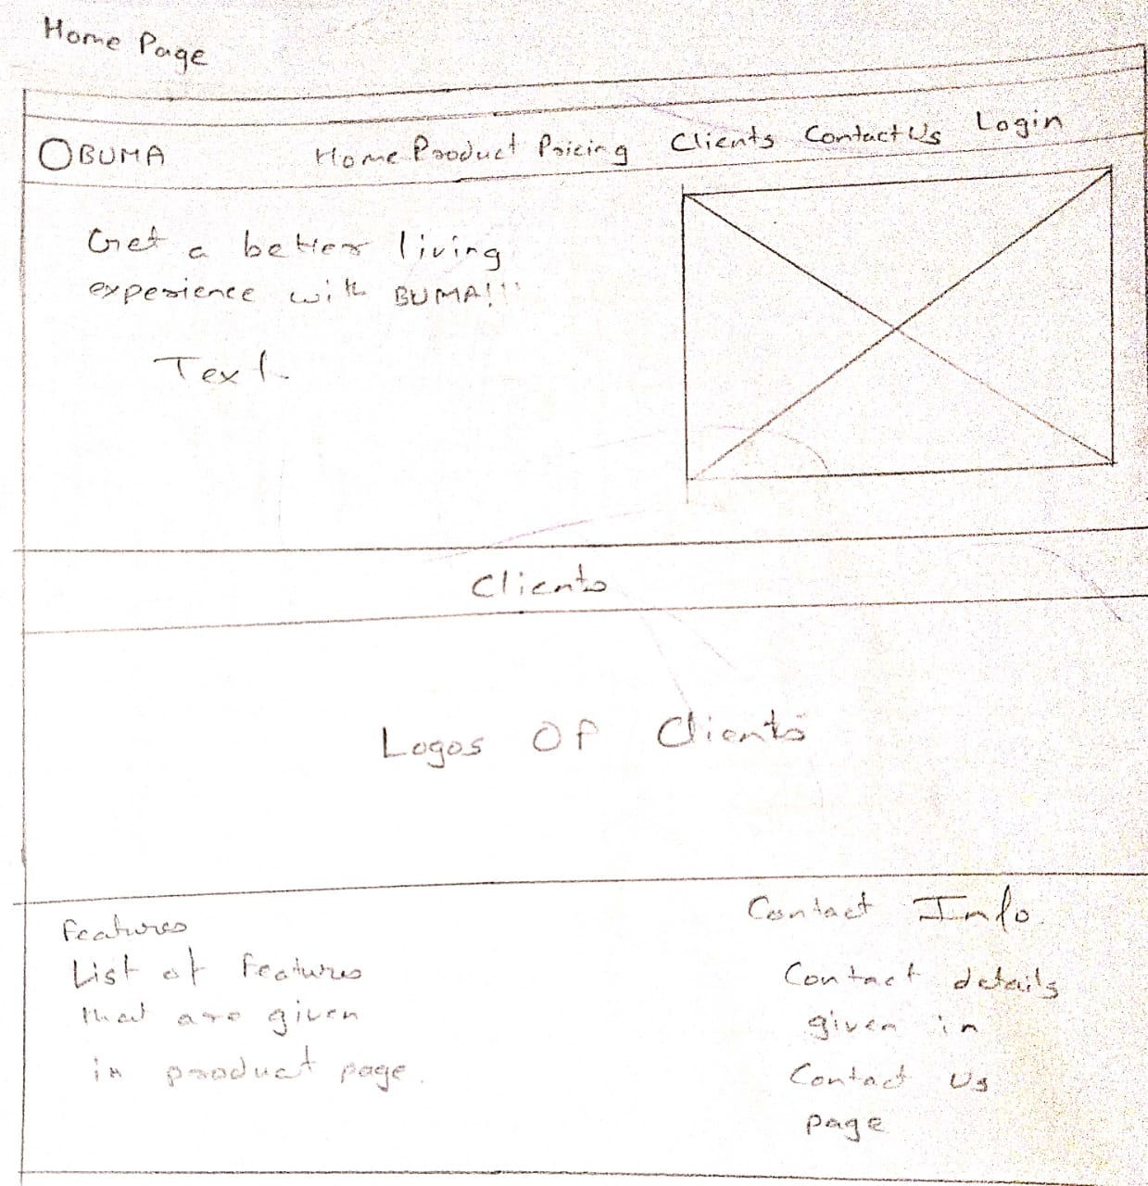

Login Page:-

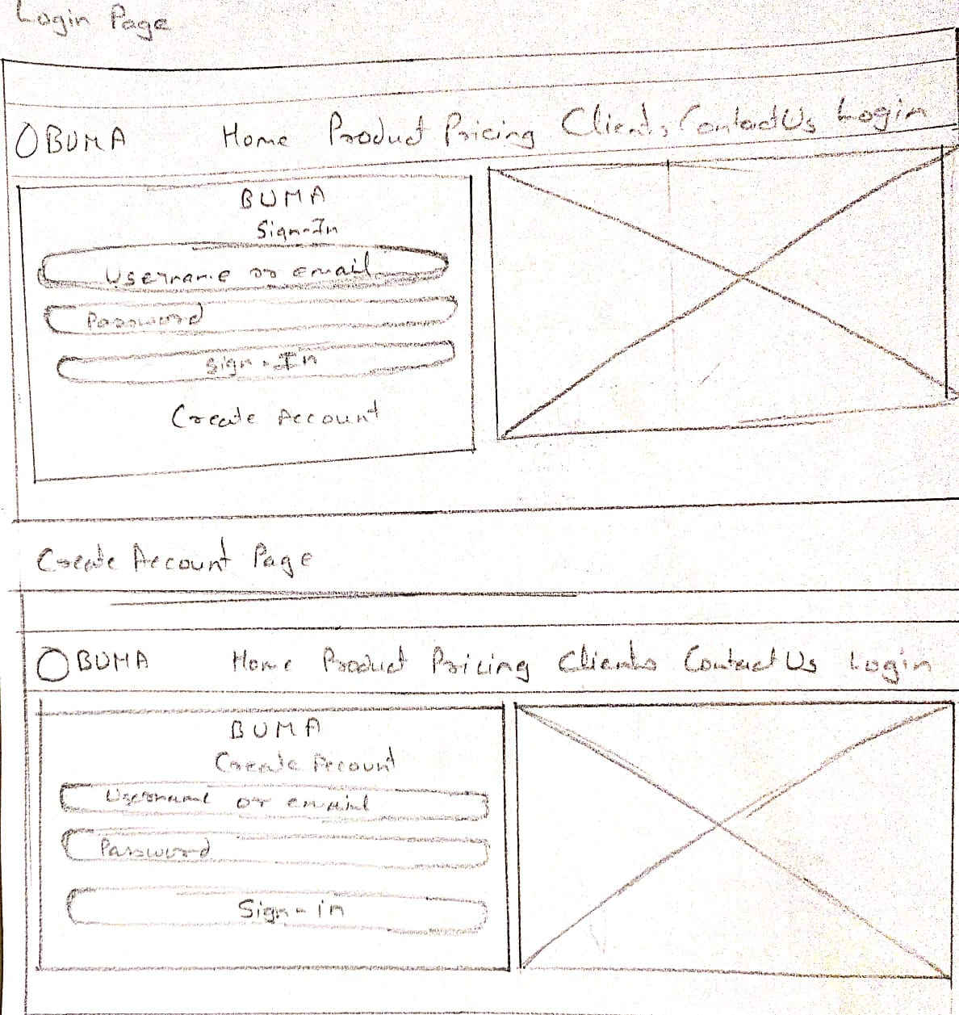

Product Page:-

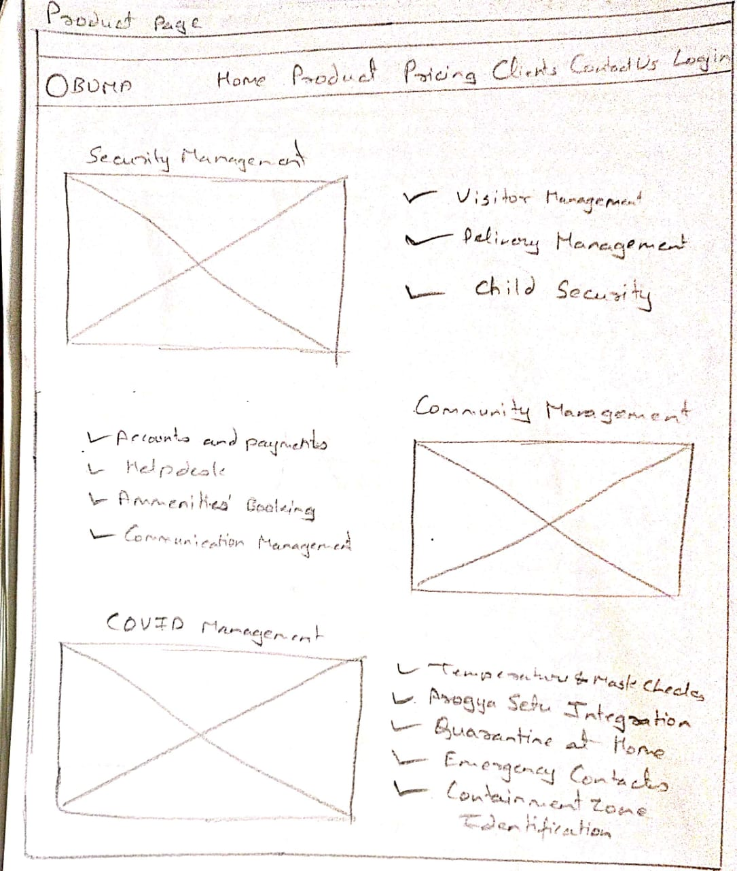

Pricing Page:-

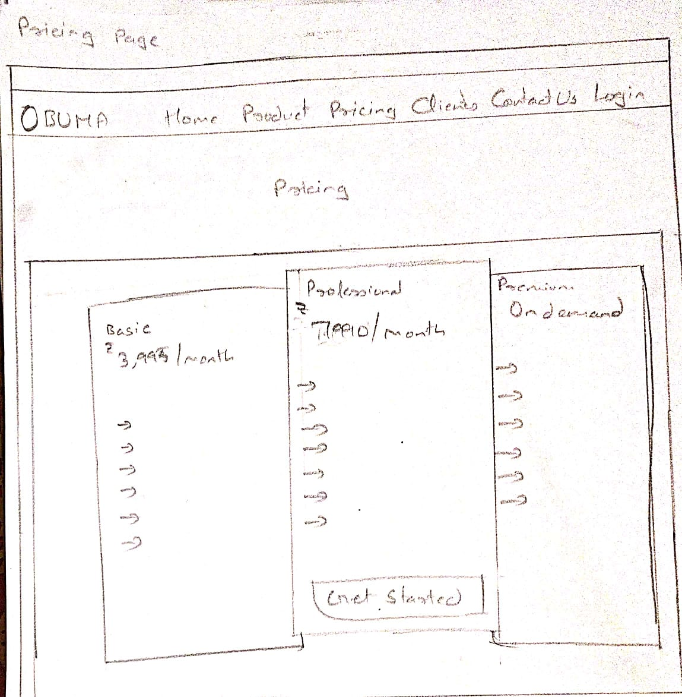

Client Page:-

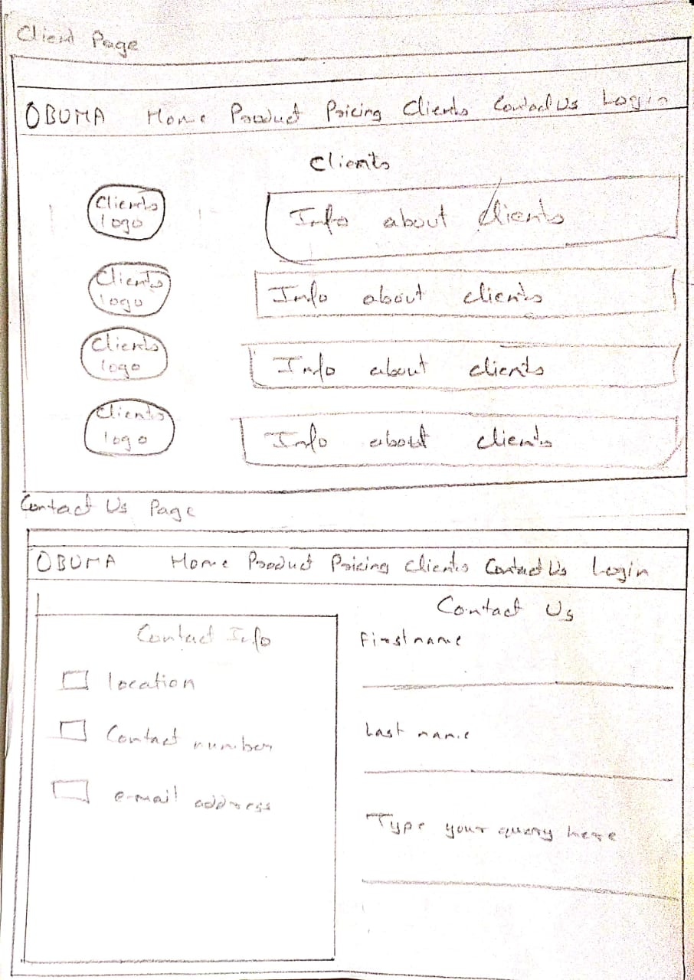

* Summary:-

This session contains the briefing about the project.

Home page consists of following:-

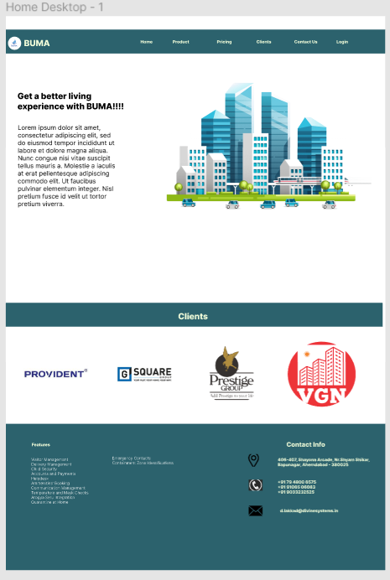

This page gives the user an idea about what the website consists of. The navigation bar contains Product, Pricing, Clients, Contact Us and Login, which can be redirected to the particular and respective web pages.

Login page consists the following:-

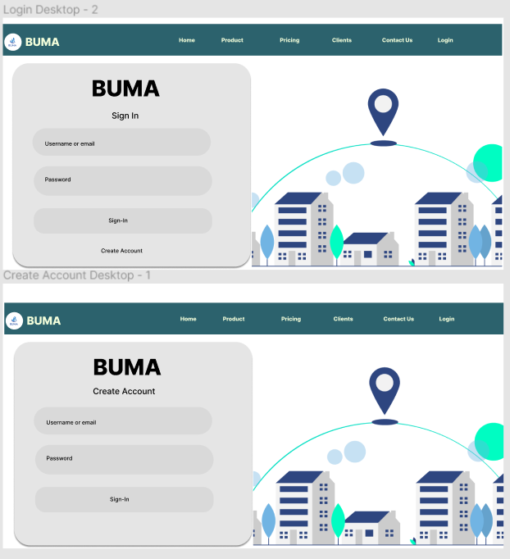

This pages asks the user for their Login credentials and if user new, the website provides the option for create account.

Product page consists the following:-

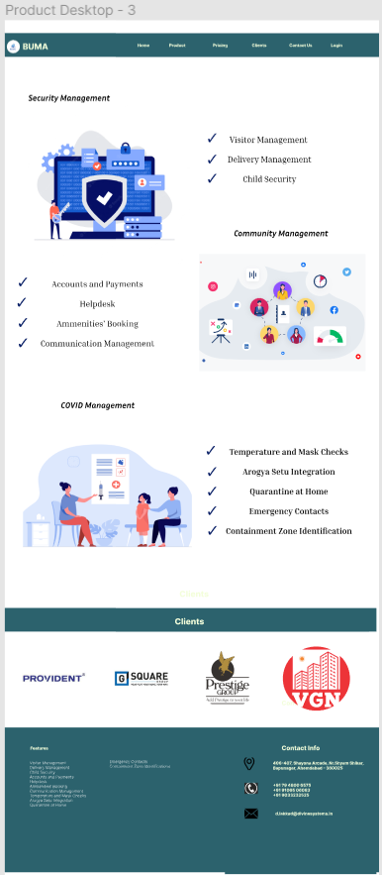

This page provides the user with information regarding the services provided by the website. They are:-

1. Security Management
2. Visitor Management
3. Delivery Management
4. Child Security
5. Community Management
6. Accounts and Payments
7. Helpdesk
8. Ammenities’ Booking
9. Communication Management
10. COVID Management
11. Temperature and Masks Checks
12. Arogya Setu Integration
13. Quarantine at Home
14. Emergency Contacts
15. Containment Zone Identification

Client Page consists of following:-

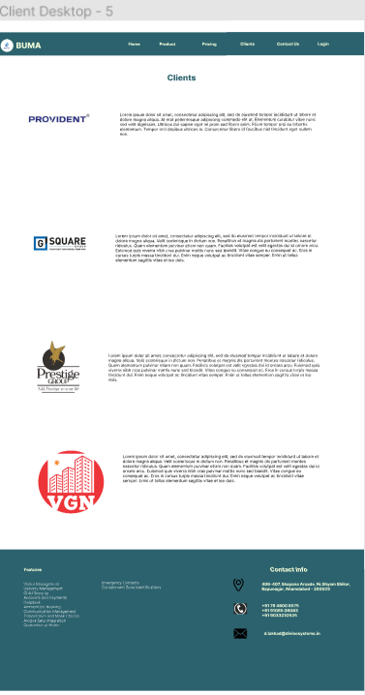

This page provides the information about the clients that are associated with the developer.

Pricing page consists of the following:-

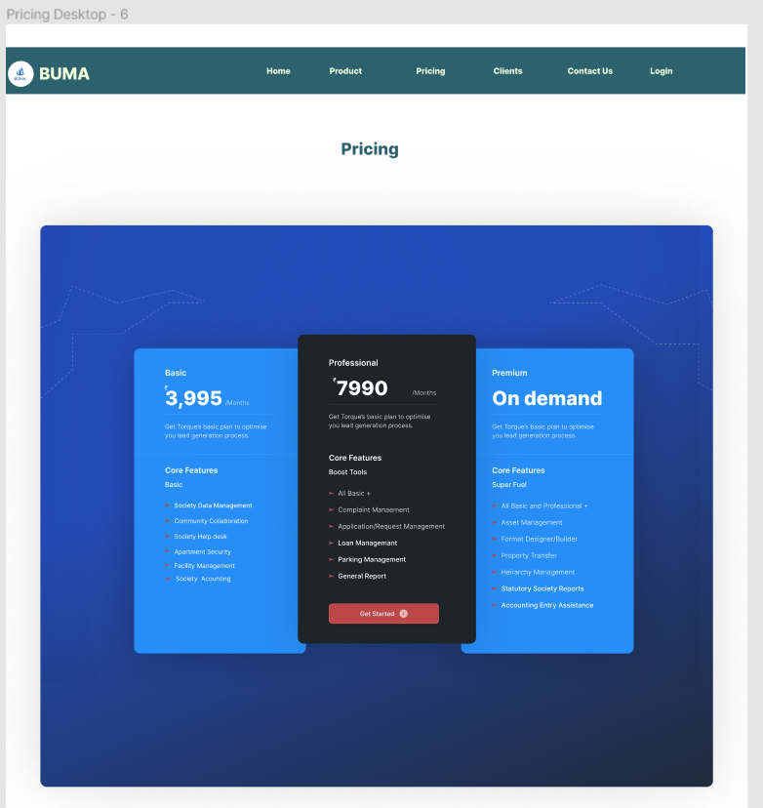

This page provides with the pricing structure of the housing management system.

Contact Us page consists of the following:-

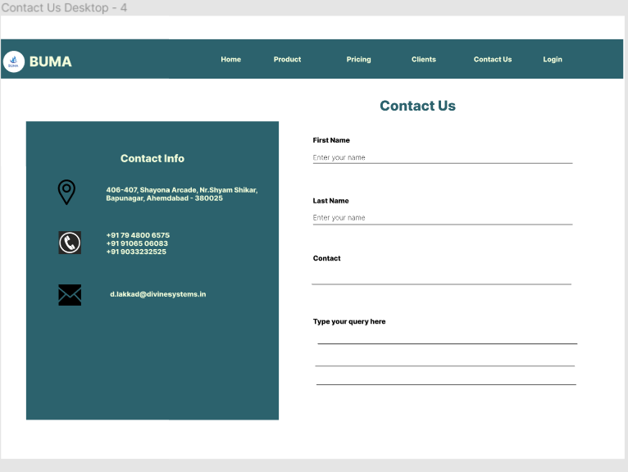

This page provides the information regarding the developer to the user and also asks the feedback of the user regarding the website.

Prototype of the website is as follows:-

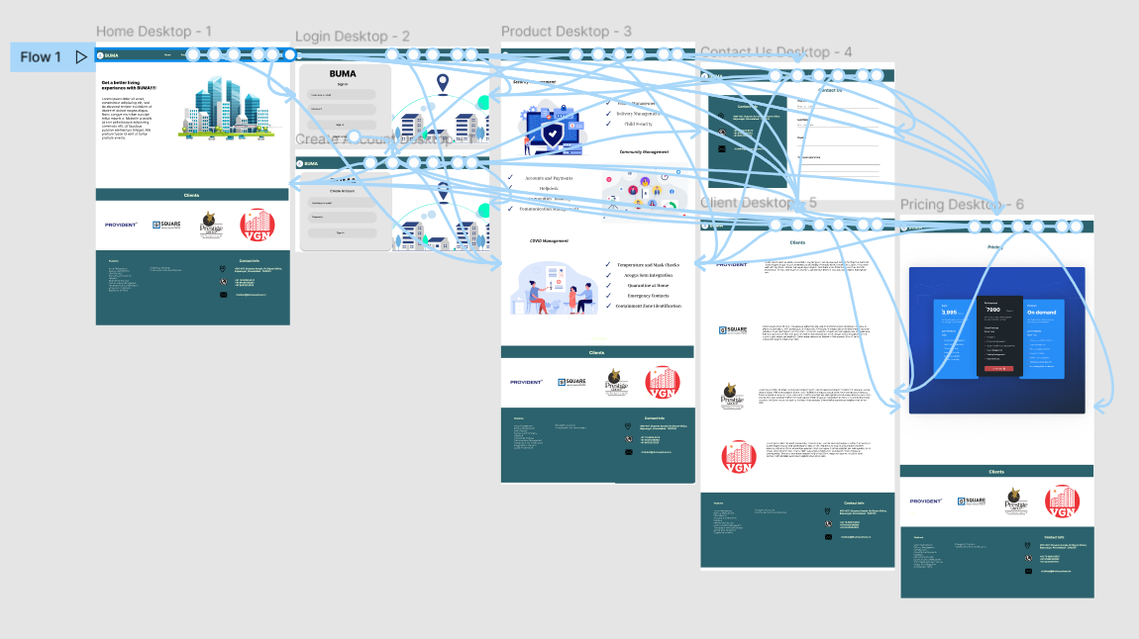

This shows how the pages are linked with each other.

* References:-

https://mygate.com/housing-society-management-

software?utm_source=Google%20Adwords%20Search&amp;utm_medium=cpc&amp;utm_device=c&amp;utm_ter

m=my%20gate&amp;utm_campaign=Ahd_Mygate_Brand_Ser_Exact&amp;gclid=CjwKCAjwtcCVBhA0EiwAT1fY

7zK2Wj5TjIynEArnYrd5p7BRvFxlqekMoqx8A-Y9QNp9ycFP71SrChoC1_kQAvD_BwE